**Signal Processing Training**

**Lab # 06**



**Fall 2023**

**CSE-402L Digital Signal Processing Lab**

Submitted by: **Ali Asghar**

Registration No.: **21PWCSE2059**

Class Section: **C**

“On my honor, as student of University of Engineering and Technology, I have neither given nor received unauthorized assistance on this academic work.”

Submitted to:

**Dr. Yasir Saleem Afridi**

Date:

**30th October 2023**

**Department of Computer Systems Engineering**

**University of Engineering and Technology, Peshawar**

**CSE 402L: Digital Signal Processing**

|  |  |  |  |  |
| --- | --- | --- | --- | --- |
| **Demonstration of Concepts** | **Poor (Does not meet expectation (1))**  The student failed to demonstrate a clear understanding of the assignment concepts | **Fair (Meet Expectation (2-3))**  The student demonstrated a clear understanding of some of the assignment concepts | **Good (Exceeds Expectation (4-5)**  The student demonstrated a clear understanding of the assignment concepts | **Score**  **30%** |
| **Accuracy** | The student completed ( <50%) tasks and provided MATLAB code and/or Simulink models with errors. Outputs shown are not correct in form of graphs (no labels) and/or tables along with incorrect analysis or remarks. | The student completed partial tasks (50% - <90%) with accurate MATLAB code and/or Simulink models. Correct outputs are shown in form of graphs (without labels) and/or tables along with correct analysis or remarks. | The student completed all required tasks (90%-100%) with accurate MATLAB code and/or Simulink models. Correct outputs are shown in form of labeled graphs and/or tables along with correct analysis or remarks. | **30%** |
| **Following Directions** | The student clearly failed to follow the verbal and written instructions to successfully complete the lab | The student failed to follow the some of the verbal and written instructions to successfully complete all requirements of the lab | The student followed the verbal and written instructions to successfully complete requirements of the lab | **20%** |
| **Time Utilization** | The student failed to complete even part of the lab in the allotted amount of time | The student failed to complete the entire lab in the allotted amount of time | The student completed the lab in its entirety in the allotted amount of time | **20%** |

Lab 6: Signal Processing Training

Title: Signal processing onramp

Learn basics of practical signal processing techniques in MATLAB. Use spectral analysis and filtering techniques to process, analyze, and extract information form signal data. Visit the following website: <https://matlabacademy.mathworks.com/details/signal-processing-onramp/signalprocessing> and perform the following tasks and attach the Certificate/ Progress Report acquired from MathWorks as part of the lab Report

Objectives

1. Course Overview
   1. Familiarize yourself with the course.
   2. Remarks along with final snapshot.

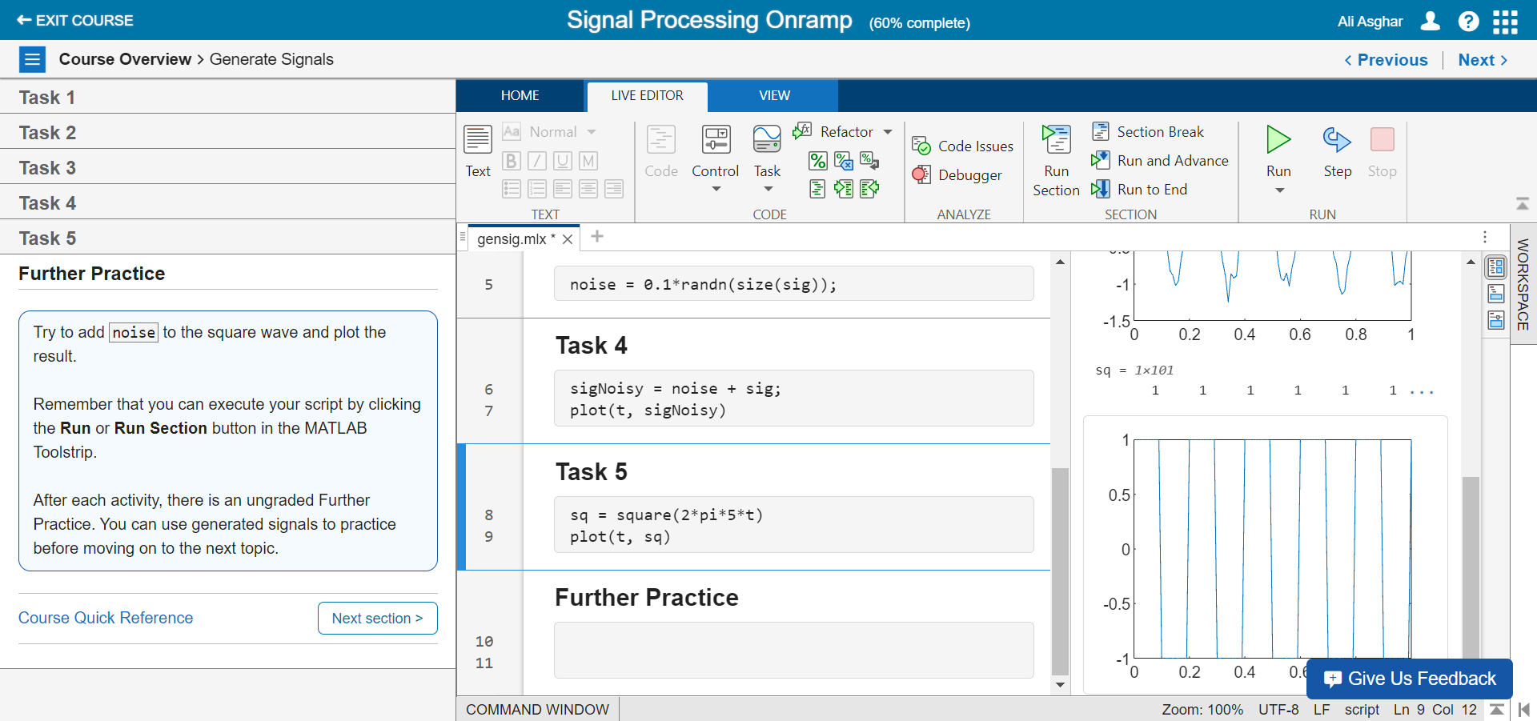

**Remarks:**

In this first module, I generated a sine wave with 100 sampling frequency using sin() function.Then I added some random noise(using randn) into sine signal. After addition of noise signal with sine wave I obtained sigNoisysignal.I also did the same procedure for the square signal.

1. Spectral Analysis Workflow
   1. Import Signals into MATLAB and view power spectra.
   2. Remarks along with final snapshot.

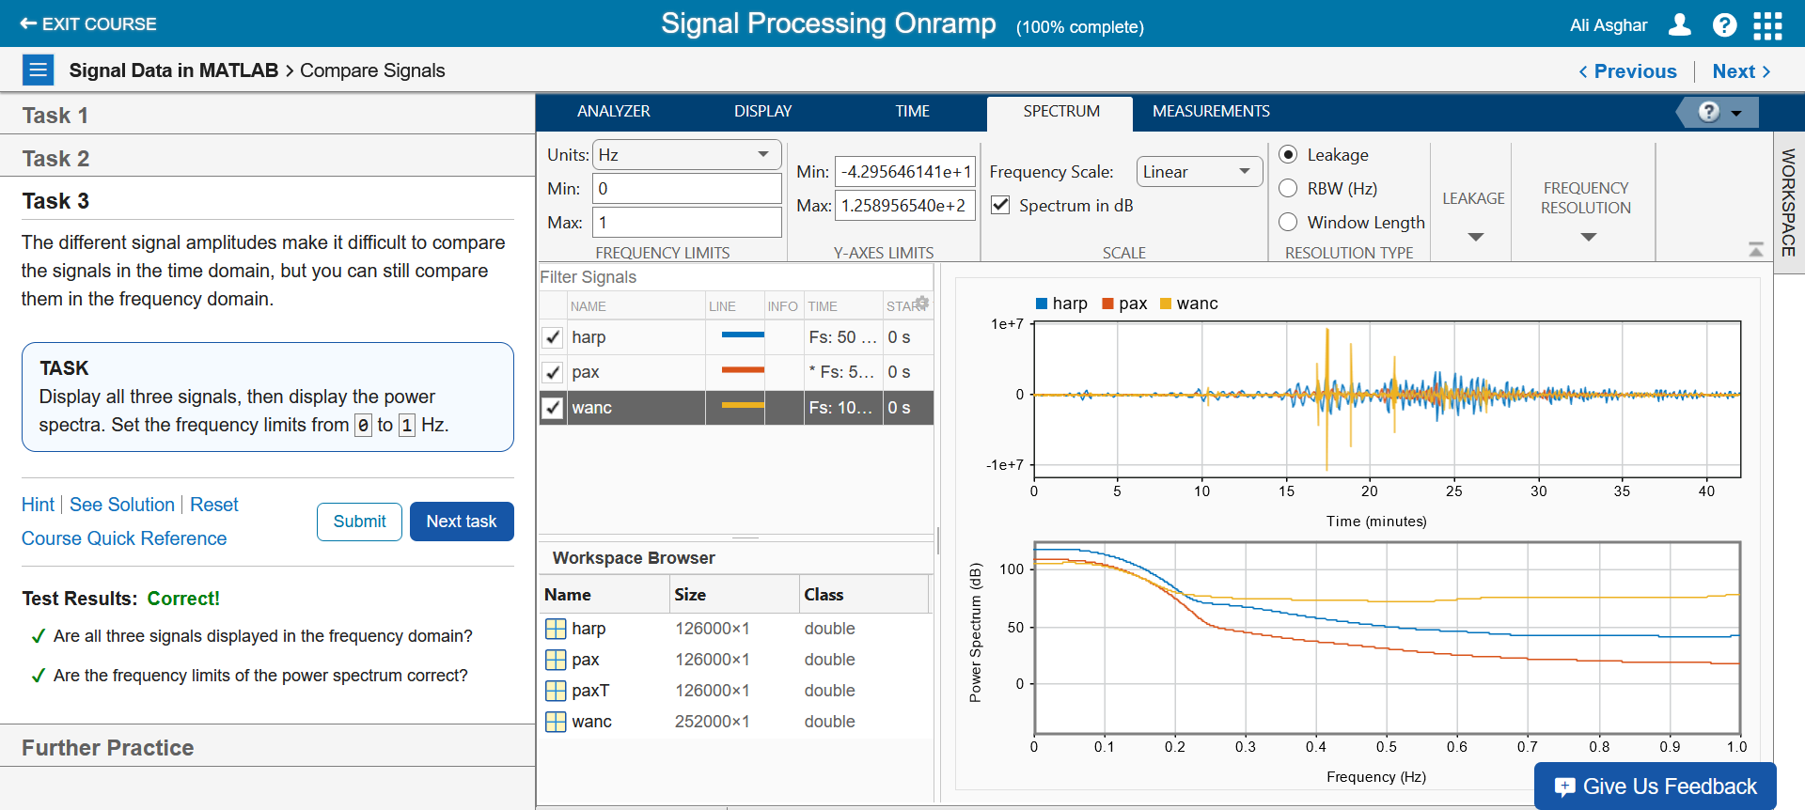

**Remarks:**

First, I obtained the time steps form the seismicstation_ts.csv. Then I pre-process the signal and set its tstart and tend by using pspectrum function. Next, I plotted the power spectrum of harp signal by using pspectrum function. Next, I created two more signals namely pax and wanc, compared both with harp signal. Finally, I represented the signal in signalAnalyzer function in order to inspect its behaviour.

1. Preprocessing Signals
   1. Clean up time base and align signals.
   2. Remarks along with final snapshot.

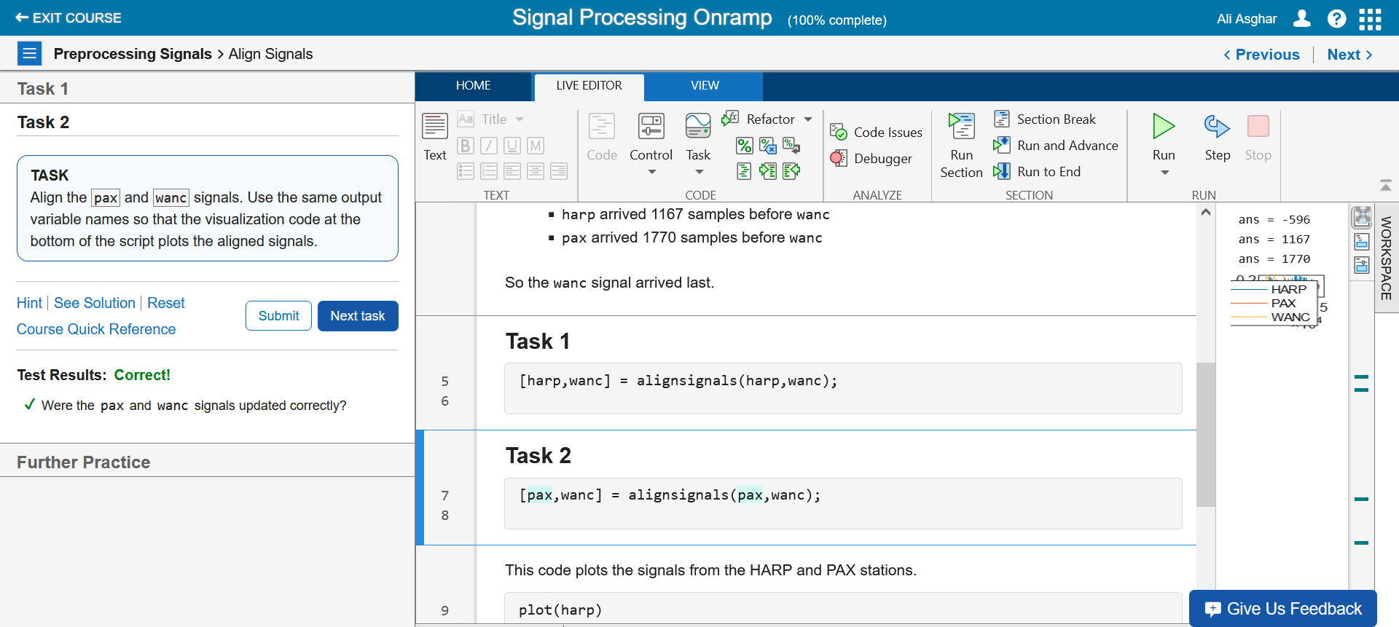

**Remarks:**

I resampled the behavior of harp, pax and wanc signals. I found that the cross-correlation of harp signal and gave a delay by using finddelay function. After this, I synchronized the harp, pax and wanc signals and plot the stacked plots of these signals.

1. Spectral Analysis
   1. Perform spectral analysis to view signals in the frequency domain.
   2. Remarks along with final snapshot.

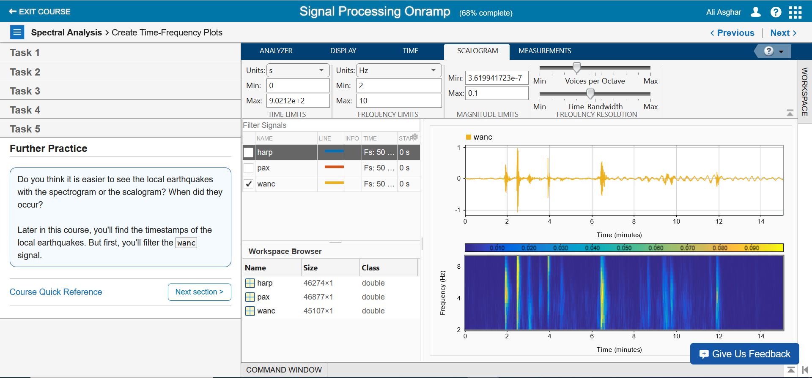

**Remarks:**

I established the power spectrum of the signals and generated a semilog plot for them. I added a legend to distinguish the harp, pax, and wanc signals within the figure. Afterward, I conducted the time-frequency analysis, and ultimately, I plotted the time-frequency plots using both spectrogram and scalogram methods.

1. Filtering
   1. Filter signals using basic techniques.
   2. Remarks along with final snapshot.

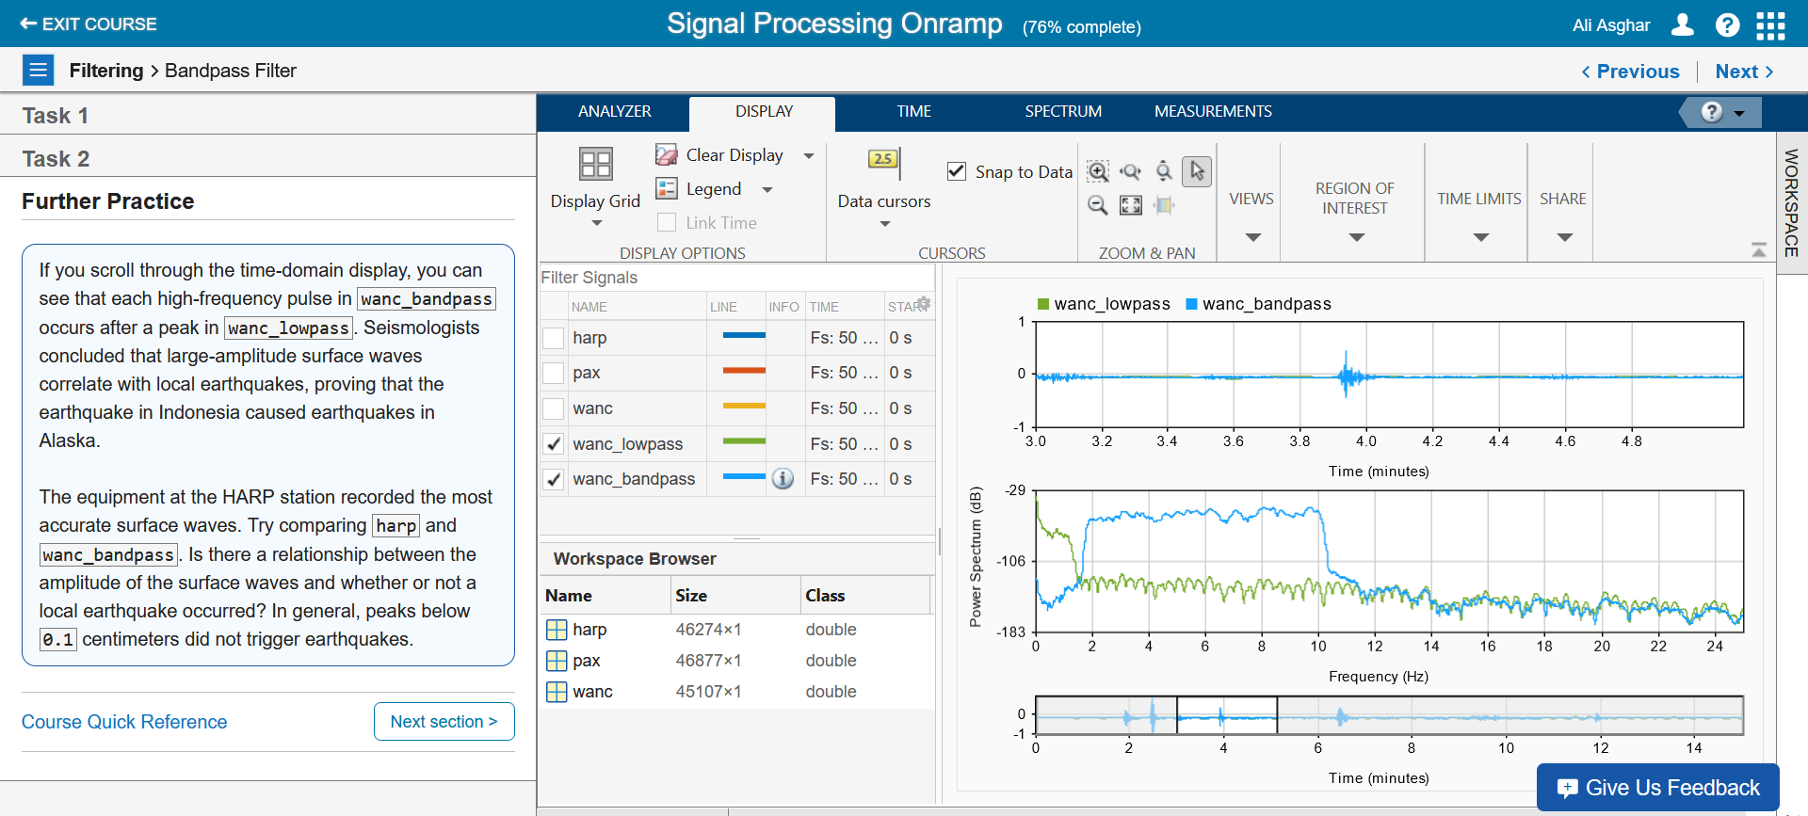

**Remarks:**

I applied the lowpass filter function to the 'wanc' signal, and after filtering, I appended it to the table. Then, I passed the 'wanc' signal through the bandpass filter function, resulting in a new table. I combined this new table with the existing one.

1. Signal Measurements
   1. Extract information from signals.
   2. Remarks along with final snapshot.

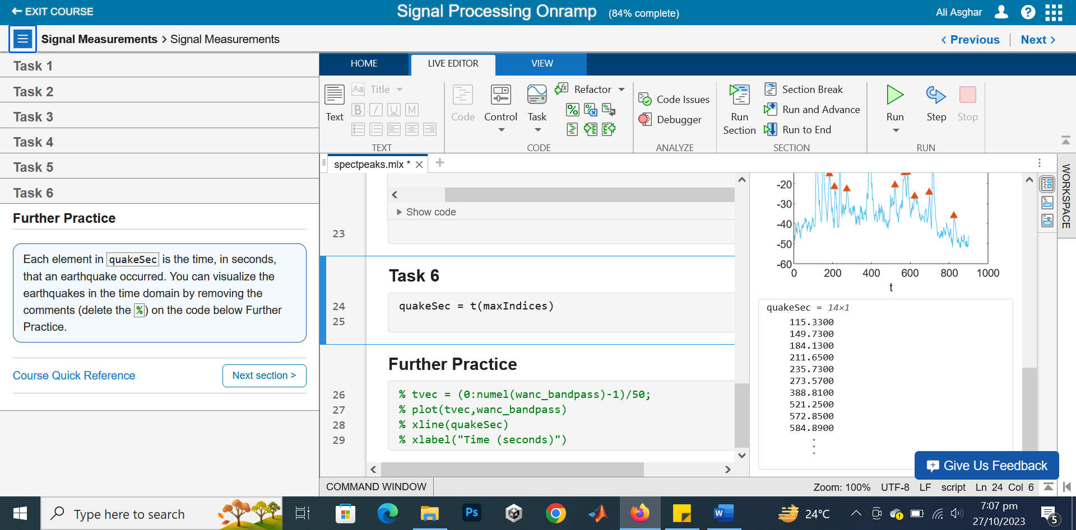

**Remarks:**

I updated the spectrogram by adding three additional arguments, which are 'p,' 'f,' and 't.' After that, I computed the sum of 'p' and created a spectrum plot for it, labeling it as 'psum.' To calculate the power of 'psum,' I plotted its spectrum as 'pwr.' Lastly, I incorporated the 'Find Local Extrema' into the code section.

1. Conclusion
   1. Learn next steps and give feedback on the course.
   2. Remarks along with final snapshot.

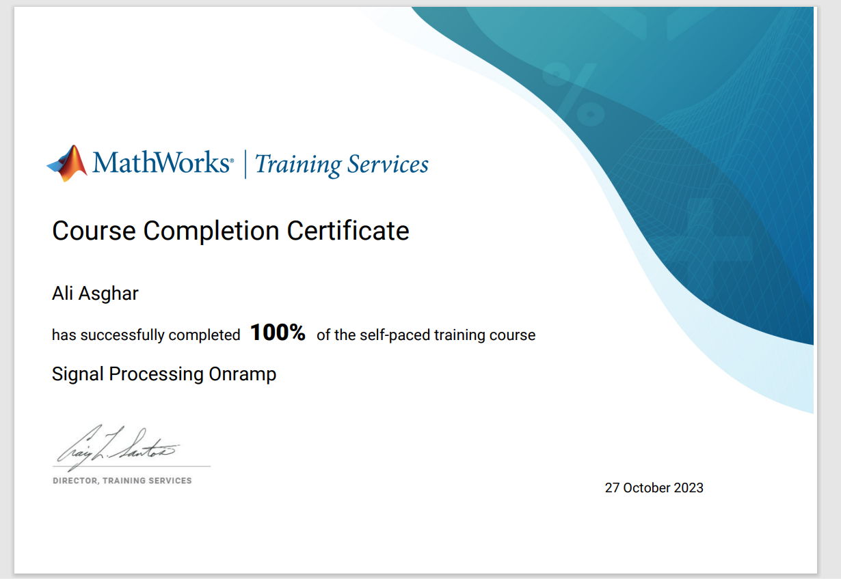

**Remarks:**

I learned the basic concepts of signal processing and the various methodologies used to analyze signal behavior. In one example from the course, I examined different types of waves such as harp, pax, and wanc. I observed the behavior of these waves using a spectrum analyzer. Additionally, I used the pspectrum function to generate power spectra for harp, pax, and wanc waves. I also created time-frequency plots using spectrograms and scalograms. Throughout the course, I explored filtration processes, including lowpass and bandpass filters, which allowed me to gain a better understanding of how these filters affect signal behavior.